Install

- open the CD, copy GM MID folder into your PC.
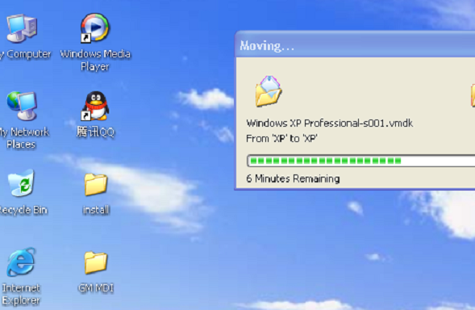

- double click GM MDI folder on your PC, and install VMware8.0
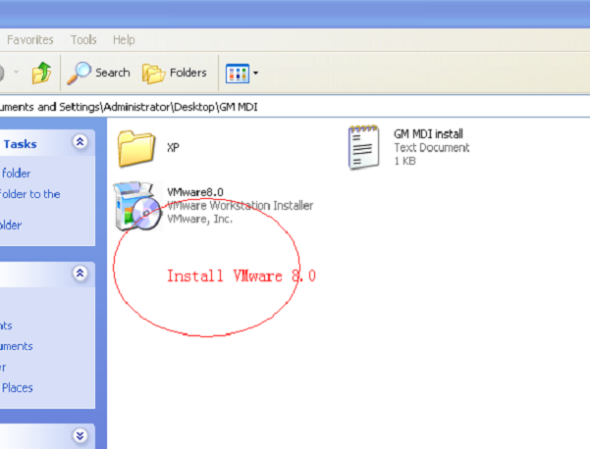
- double click VMware8.0 icon on your desk to Run VMware8.0 software

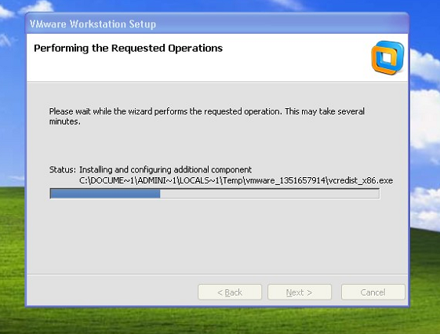
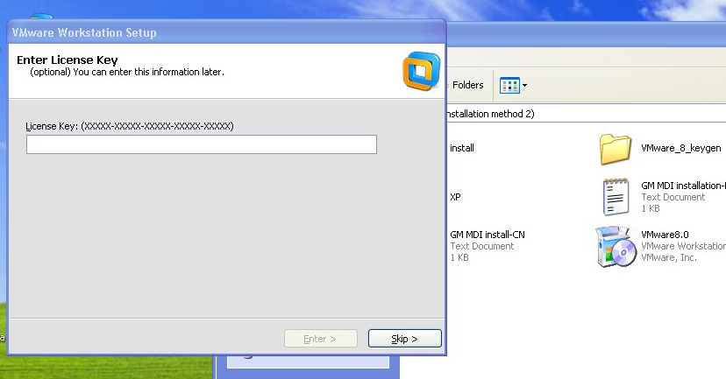
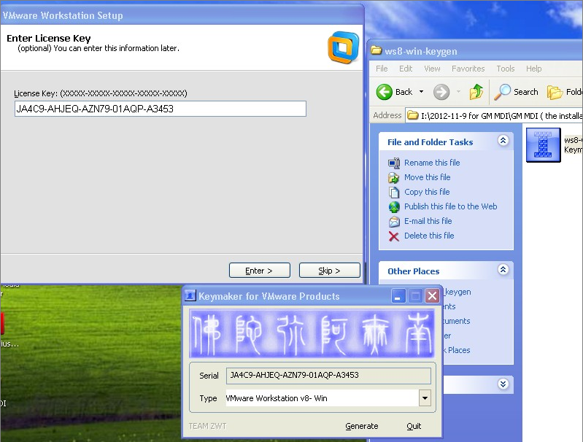
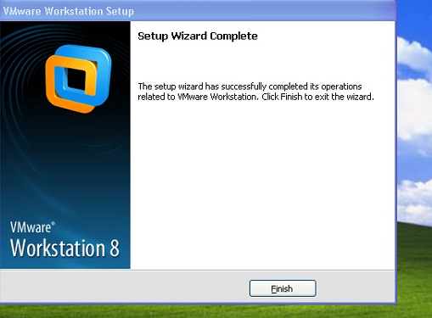

- Open GM MDI folder on VMware8.0, and choose "windows XP professional" on XP folder.
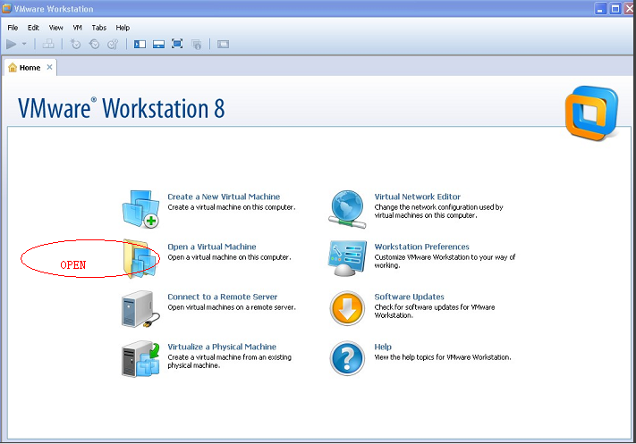
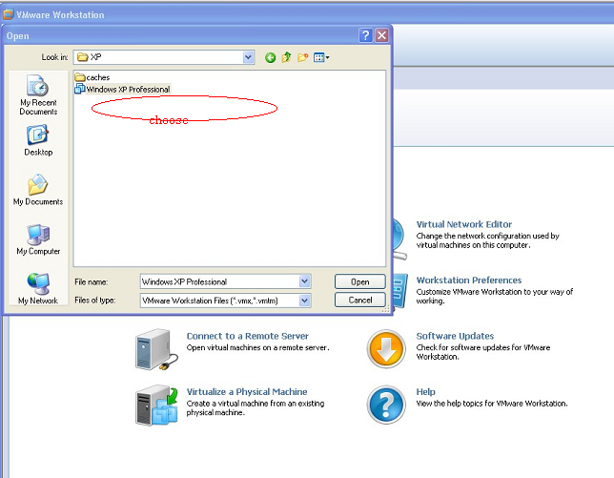

5. Run virtual operation systerm" windows XP professional "
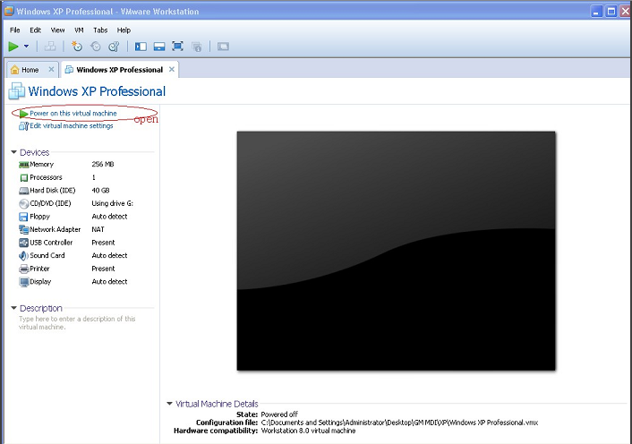

NOTICE !!!
Choose: I moved it
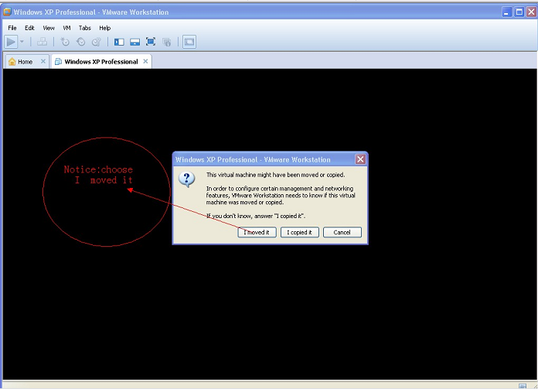
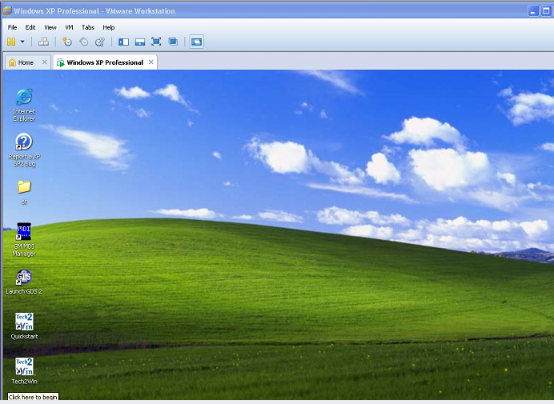

6. connect MDI to your PC and vehicle,and it is ready to use.

